Tiffany Bailey

Gabrielle Gaulin

Jessica Nielsen

Zaiyuan Xiao

Wrought iron to tubular steel: from antiquity on

The Romans originally used iron for its strength to replace their bronze arms; it was considered a near precious metal due to its difficulty of extraction and difficulty to work, so durable iron chairs were prized items. Iron continued to grow in use because of its practical applications, becoming even more elaborate in response to the taste of the times. As time went on, techniques and skills developed and iron furniture developed amazingly varied textures and patterns. During the Arts and Crafts movement of the 19th century, iron was valued for its durability and simplicity, reflecting the idea that art and architecture should return to a focus on quality. After the advent of the casting process for iron, cast iron furniture became a common commodity and reached the peak of its popularity. The casting process allowed artists to experiment freely with elaborate and creative designs which suited mass appeal instead of a single patron’s. Finally, steel was invented, increasing in strength and the workability over iron. When it became available at a lower cost, it was picked up by designers for strong support for furniture with a streamlined look.

Iron went through many forms. Beginning with the Romans, it was used in the lasting and popular x-frame chair. As a chest, iron offered intense security and fireproofing. Locksmiths created elaborate techniques to embellish these very practical and secure safes. Later, iron became popular in bed frames, for its strength, cleanliness, and resistance against bugs. It was also used widely in architecture, specifically in churches and cathedrals, in elements such as railings, archways and windows. Scrolling, ornate cast iron benches and chairs became popular for their outdoor applications in addition to its interior uses. Mass production allowed artisans to make elaborate designs that could be easily replicated through molds, democratizing iron’s use for the first time. In modern furniture, tubular steel design developed as a minimalistic counterpoint to the scrolled tubes of iron of earlier days. Due to the Bauhaus Movement, architects and designers became fixated with developing a minimalist cantilever chair using steel tubing. Throughout furniture history, iron and then steel’s practical properties of strength and durability have ensured it a place in artisan’s hearts.

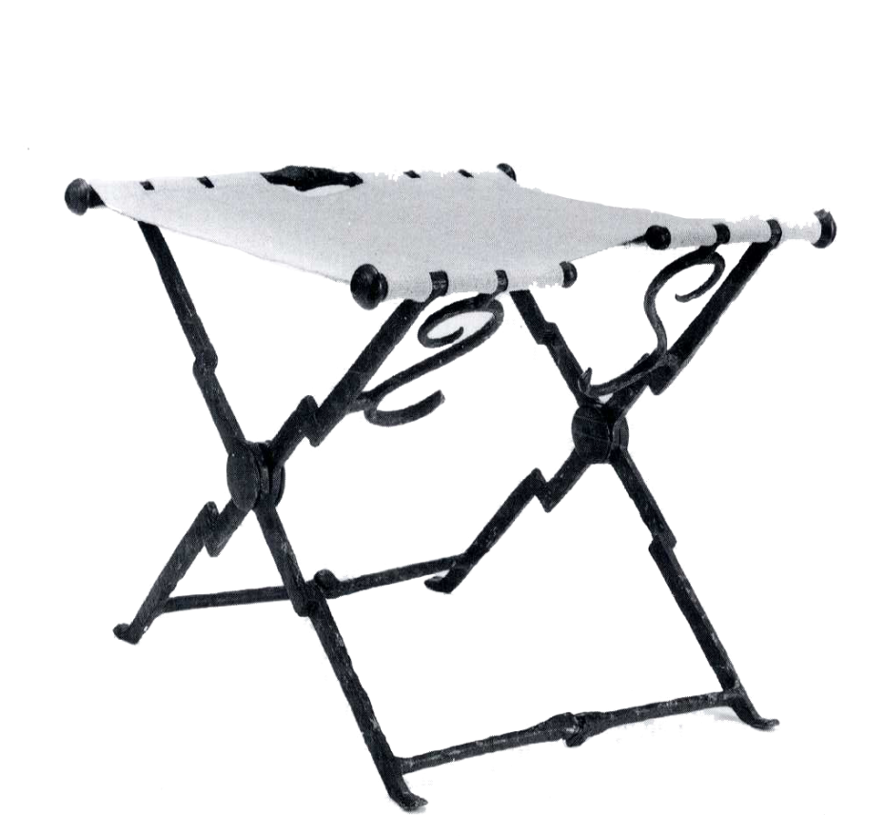 The earliest recorded metal furniture was created by the Romans, beginning from the 1st century A.D. (#, 11). Strong geometries ruled their structures and are reflected in the Romans’ biggest legacy to furniture: the *sella curulis*. The *sella curulis* is an X-frame chair that bears resemblance to the wooden variety shown in Egyptian paintings, although without any animalistic ornamentation. Also similar was the connotation of power or prestige associated with the chair. The X form helped to distribute weight and support the sitter, which is why the Romans, ever the engineers, chose this shape. This shape also allowed the *sella curulis* the flexibility to close into a linear form.

Roman, 3rd century AD

A highly practical form called for a highly practical and very hard material, which was found in iron. The metal which the Romans used to produce both weapons and other manufactures was often bronze or iron, both of which, after being nearly exhausted in Rome, were imported from Spain and Britain (*, 338). Although very difficult to extract and work, it is an extremely durable surface; because of the higher level of craftsmanship required to work iron, it was considered as a material of special status, thus enhancing the status of the chair. This idea survived up through the 18th century. (#, 11) Extra details such as copper and bronze inlay were also common additions to beautify these chairs.

This chair spread throughout Europe due to the Roman reach on the ancient world. The Romans had unprecedented access to world markets and ideas, and their influence was undeniable in Europe and Asia. The Roman Empire consisted of a vast tract of lands at its peak and was actively involved in international trade with its colonies and vassals, as well as non-Roman Africa, India, and even China (*, 339). Powerful emperors ruled over the domain for hundreds of years, although towards the 1st and 2nd century AD periods much of the actual maintenance of empire was delegated to his lowers, including senators, prefects, and magistrates (*, 331). The Roman culture was very focused on power and respect. There was huge class stratification, concentrating all political power and most of the wealth amongst the *honestiores* (honorable people) versus the *humiliores* (commoners) (*, 333). The unskilled commoners were often placated with displays on violence on the stages of Rome, such as the famous gladiatorial battles, mock naval encounters, and animal fights (*, 202). The overall emphasis on strength, both physical and mental, as well as triumph over enemies had a considerable impact on many facets of Roman life, not only politics, but also the arts

The Romans had a proclivity for Greek styles, both in art and education, which reflected their interest in powerful peoples. The strong lines of Greek work, seen through the vestiges of Greek architecture and sculpture, appealed to the Romans; however, the Romans took the styles they favored and modified them slightly to fit their purposes, focusing on increasing the strength. Great engineers and architects, the people of the Roman Empire are responsible for many spectacular monuments which still stand today, such as the Pantheon and their famous aqueduct system, which spanned their wide reaching empire. The Romans modified Greek architecture, based on the post and lintel, to become even statelier with the inventions of concrete, which allowed for significantly more stable building (*, 211), and the arch/barrel vault. (*, 340). The strong geometric forms favored by the Romans can be further seen in the s*ella curulis* they presented to the world.

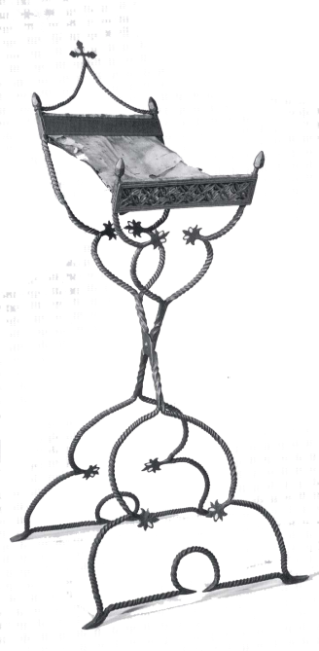The *sella curulis* continued to spread throughout the once Roman world. This special chair was the only piece of furniture made in metal for a long time, although variations were created, such as this lectern which would fold for storage at a single pivot. The *sella curulis* continued to have connotations of power, seen as the seat of honor for first secular and then gradually religious leaders in the late Middle Ages. (#, 11) In the Gothic period, this form was popular in cathedrals both as seats and as the lectern shown.

Spanish, 16th century

The X-frame lectern pictured above was used to hold the Bible during mass services. The elaboration of the basic X-frame of the past fits the artistic stylings of the period, with scrolled metal and elaborate relief work. The Spaniards have taken a strict and geometric base and softened it to suit the Gothic style. Small details such as the long, narrow shape of the “seat” and the floating cross at the top help to indicate the lectern’s purpose. Similarly, the use of the X-frame indicates the stature of this object and elevates the book it holds, both literally and figuratively. The X frame also echoes the cross in shape, emphasizing the object’s religious significance and the significance of Catholicism to the Spaniards.

The Spanish in the 16th century were hugely powerful and wealthy, with a king who was able to sack Rome, establish dominion over the Netherlands and parts of Italy, and import huge quantities of precious metal from the New World. (@, 267) Catholicism was heavily endorsed and the Spaniards felt it was their moral duty to defeat the “heathens” of both Europe and the New World and show them the proper path. Therefore, the role of the Catholic Church and local cathedrals were hugely important. The aristocracy took on the role of “Christian warriors”, elevating themselves over the infidels of the empire with their high ideal of honor through conquest (@, 268-9); this concept of the self was shared by even the poorest classes, particularly Castilians, who prided themselves on their “pure blood” (@, 285). They made great efforts to eliminate the outliers of the Kingdom such as Jews and Moriscos. The Moriscos (Muslims living in Spain) were pressured to abandon their cultural traditions and conform to the Catholic majority (@, 286). One could argue that the “embarrassing” inclusion of these religious minorities was one of the reason the monarchy heavily emphasized their Catholic background and beliefs. The only way to advance in society was through military or clerical excellence. (@, 271)

Spanish art at the time was heavily influenced by the vestiges of the Italian Renaissance, as well as Northern influences from the Netherlands and some of Spain’s own deeply religious national culture. The main patrons of art were the church, monasteries, and religiously focused aristocrats. Although the impact of the Italian masters was clear, the Spanish dismissed the popular mythological themes and nudity of Italian images and chose to focus instead on mainly religious themes and sober portraiture. Towards the end of the 1500s, the style of Mannerism began to appear in Spanish art, emphasizing the religious material. (&) The elaborate art forms and their uses in society glorifying Catholicism reflected the Spanish ideals of this time.

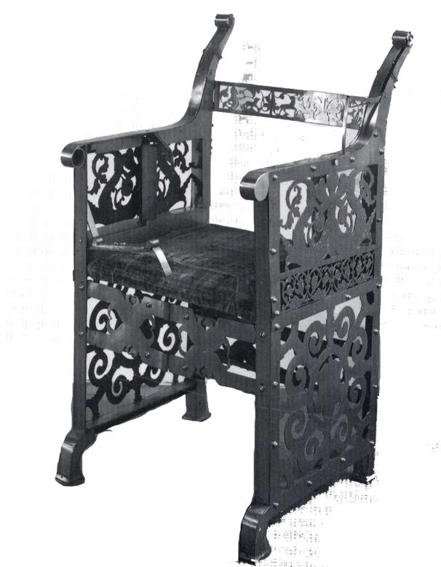This “trick chair” from Hungary in the second half of the 16th century is another example of metal craft, here without the Roman X-frame. The seat belonged to Archduke Ferdinand the Second of the Hapsburgs, one of the rulers of a then divided Hungary. ($) The chair was cleverly designed with hidden straps which would trap the person who sat down in it. Only the person who knew the mechanism was able to free the trapped individual.

Hungary, late 16th century AD

Hungary during the early 1500s was ruled by the Hapsburg dynasty, but was under siege by the Turkish sultans. Civil war broke out after the Turkish invasions backed out of the country, with the population fighting over the succession of the king; two men rivaled for the throne, Janos Szapolyai and Ferdinand Habsburg. Eventually, the empire was divided into three parts to end the constant warfare. The Turkish continued to interfere in the country’s politics with the hopes of dividing the country and eventually conquering it. The country continued to suffer civil strife throughout the 16th century. (`, political and military history) Much like other European countries at the time, society was separated by aristocracy, minor landowners, and peasants. However, nobility was accessible through money and military service. There was heavy discrimination against Turkish customs and associations, even punishable by law. (`, social history)

Artistic life during this period was virtually deadened by the extensive warfare and destruction of cities. The spread of counter-Catholic groups during the Reformation further weakened the position of the arts within the culture of Hungary, due to the popular notion of iconoclasm. Architecture was primarily militaristic and practical in nature, without much variation or relation to other European styles. Hungary was generally unwelcome to outside influence of art, and only experienced such styles through imports of the church and wealthy. The Renaissance largely bypassed the area, and the Baroque only entered later. Several acclaimed humanists served as patrons of the arts, with a major focus on illustrated books and miniatures. Libraries were highly valued and the production of books was considered an art form. Painting was popular among the courts as a glorification of the monarchies, as well as humanistic and ancestral portraits which were popular among the upper class. (`, Art)

The trick chair shown above has little in common with the previous two examples of sella curulis and lectern. Because of Hungary’s relative isolation from the influence of the Mediterranean, its styles were developing independently for the most part. In addition, the additional role of this chair as a trap was unseen elsewhere; in Hungary this type of “practical joke” furniture was popular among the aristocracy. The metal appears to be sheet metal instead of wrought iron, and worked in patterns that are not reminiscent of classical western styles but instead the scrolling of perhaps Turkish influence. This eastern European example appears to be unrelated to the classical sella curulis except for its material.

Starting in the 16th century iron transitioned into being primarily used for decorative purposes. Specifically it started appearing in cathedrals especially in architectural components such as balconies and gateways. Iron continued to gain its popularity as the nature of the material became more appealing to designers. By the 18th century while it still appeared in exterior works such as railings and gates, its use in furniture design was very popular. By the 19th century arts and crafts movement, iron had become essential to furniture design. The period began as a rejection to the current art and architectural style because it was considered excessively decorative without a purpose. Artists such as John Ruskin, William Morris and Charles Rennie Mackintosh believed art needed to return to simplistic design. They focused on reconnecting their designs to nature by referencing plants and animals. Iron became a popular option because it was a flexible material to work with but still had that toughness so it would last (“Wrought”). During the 19th century iron also was affected by the development of new technological processes and innovations. It was able to be created in larger quantities allowing for mass production of furniture pieces. This allowed for the growth of designers, as well as the popularity of the use of iron as a material “Complete”).

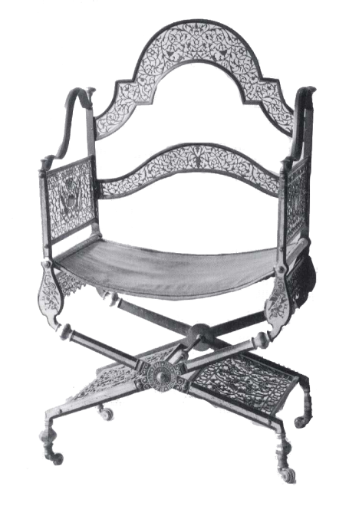Iron became popular as a material throughout this time period all over Europe. Russia was unique in that they maintained the tradition through the 18th century of producing lavish thrones and ceremonial chairs that were also folding chairs. An example of this chair can be seen in the armchair designed by Moslov Fabrik that was given as a present from Tsar Nicholas to King Frederick William IV in 1744. This chair was lavishly designed but also had the ability to be folded, reflecting the prestige still associated with the ancient Roman folding chair However, due to the continuing advancements in technology and designs, this was one of the last chairs that was produced as an indoor folding chair for some time.

Russia, 18th c. AD

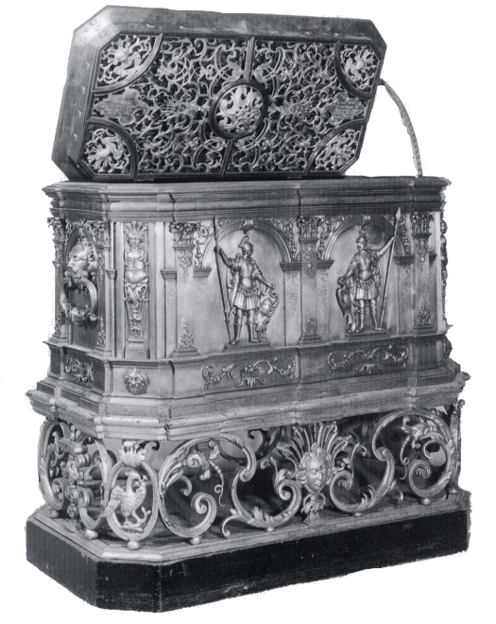 Meanwhile, in Germany in 1733, they were developing their own distinctive design trends. As seen in the chest designed by Johann Gottlieb Dittman, artistic design was developing in a way that it worked harmoniously with craft and mechanism. The ornamentation that is shown on this piece keeps in time with the trending design techniques. However, it keeps to the traditional formal shape which allows it to be recognizable of its purpose as a chest. In addition, it also experiments with the new technology of manipulating the iron. The chest appears to defy gravity as the massive chest rests on the curving ornamental forms below it.

Germany, 18th c. AD

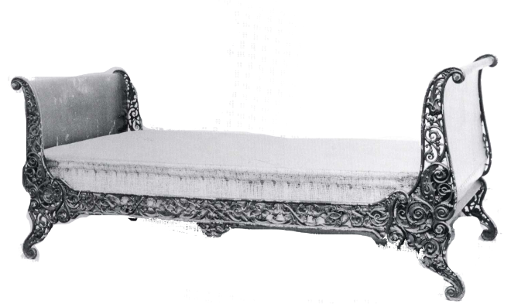 While these new designs were being developed, they also traveled throughout the continent, where they were adopted and altered to fit their cultural style. In 1840 in Hungary, the form of the Parisian iron bedstead had traveled. The form itself was modeled on a wooden bed frame, and depicts the style of its origin. The modeling of pieces after wood became popular in iron design because iron could be designed to mimic the properties of wood, both physically and aesthetically. The frame references Rococo style through its graceful and elegant form as it is ornamented with forms resembling vines and leaves. It was appealing because of its compactness and cleanliness, as iron became more and more popular in bed frames because it kept bugs from nesting in the material. The popularity of folding pieces also is referenced as the bed frame can be folded, and this compact element also appealed to many.

Hungary, 19th c. AD

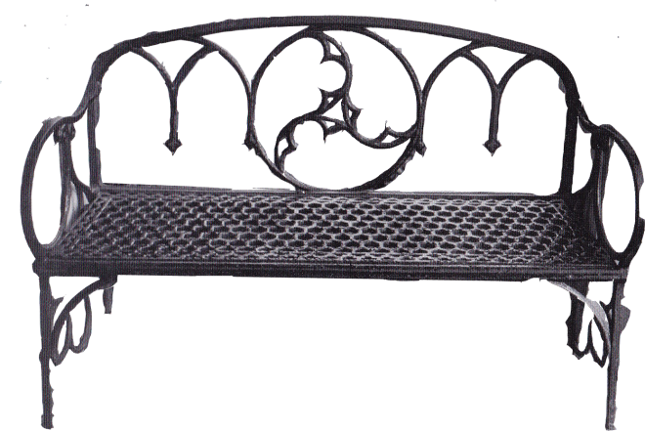A movement which started modestly in the first cast-iron bridges, cast-iron Gothic has been given a new direction by the tracery bench created by Washington Irving and George Harvey. Irving’s bench for Sunnyside is designed for a garden setting. As a result, almost all the bench is constructed by iron, which is relatively impervious to the weather. The backrest was designed with three simple but proud arches, which serve both aesthetic and structural purpose. The back, arm rests, and legs of the bench are a continuous entity, which creates a beautiful “flow”. Born into the Victorian era, when numerous styles were used as design elements, the bench reflects the popular aesthetic as well as the new disposition towards leisure and gardening.

England, 19th c. AD

The Victorian Era was a prosperous period in England from around 1837 to 1901, where the growth of consumerism as well as improvements in transportation and shipping led to a boom in demand and manufacture. Train, stagecoaches, canals and steam ships made it possible for faster transportation of goods. A thriving industry enabled the country to flourish in other areas. In terms of entertainment, besides literature, music and opera, new public areas started to emerge, such as gambling and dining clubs. In the context of visual art, there were numerous popular artists, including James Whistler and John Fitzgerald. French Impressionism painter Claude Monet was also active at the same time.

When tubular steel furniture was developed in the late 1920’s, it was mainly designed by architects. During this time in Europe the architects were designing buildings and furniture that would completely break them away from the designs of the past. The development of tubular steel was provided by the context of the post war period, and artists began to use this development as an escape from the designs of the past. Architect Le Corbusier was one person who helped to push this change by describing new buildings to be “machines for the living”, which would imply using materials that were mass produced or even physically imply the use of a machine in its production. Since buildings were “machines for living” it is only appropriate for the furniture to match the building, which came to be “machines for sitting”. Tubular steel became a very important element because it was transparent, lightweight, strong, hygienic, economical, boldly new and modern, as well as embracing the machine-like imagery of the designs during that time. Architects thought that furniture using this material was a great fit for the new spaces they were designing that were open and free-flowing.

Even though architects and designers were trying to stray from the designs of the past, many of the initial tubular-steel designs came from inspirations of bentwood furniture. These designs translated very well because of bentwood’s popularity and metal and bentwood’s shared properties of flexibility and smooth curves. Some of the greatest bentwood designs came from the Thonet design firm. Naturally, this firm also tried to get its hands into the new way of designing furniture. During the 1930’s, Thonet and tubular steel furniture became synonymous, but not for the initial reasons that one would think. They were not the first to develop a tubular-steel design, nor were they the first to market one of their tubular-steel designs. However, they were largely responsible for the reputation and popularity of tubular steel, as well as being the largest company to sell this furniture.

Yes, Thonet was not the originator of tubular-steel furniture; their initial expertise was in bentwood. However, they did have a connection to the architect who did. The first to develop a tubular-steel design was the architect Marcel Breuer, in 1925 at the Bauhaus. Thonet purchased their first tubular-steel designs from Breuer. With his own firm, Standard Möbel, Breuer did not have much success with marketing his furniture. In 1928, Breuer sold the rights to a number of his designs to Thonet. Soon after, Thonet ended up taking over Standard Möbel. Thonet proceeded to produce the first Breuer chairs and tables in the latter part of 1928. At the same time, the firm issued their first steel catalogue which included 19 of Breuer’s designs. The next catalogue they produced for tubular steel was generally uncomplicated designs that were manufactured from a minimum of bent steel. His designs have been described as direct, logical, and restrained. The architect himself referred to them as “styleless”.

Marcel Lajos Breuer was born in 1902 in the provincial city of Pecs, Hungary. While he studied and taught at the Bauhaus in Germany, during the 1920’s, he was introduced to more established artists who had already established their legacy. Three of these artists were Le Corbusier, Mies van der Rohe, and Walter Gropius. These artists have all been an influence to his career. In 1935, when Breuer left Germany he had established a pronounced reputation for himself. Breuer became known for his development of tubular-steel furniture, shop interiors, the architecture of one big residence and two apartment houses, as well as several of his competition entries. By 1937 he was asked by Walter Gropius to join Harvard’s architecture faculty. The faculty eventually came to be the American House Design during WWII. He then started his own firm in 1946.In 1968 he won the AIA Gold Medal and the first Jefferson Foundation Medal. The latter foundation described him as “among the living architects of the world as excelling all others in the quality of his work.” He finally retired in 1976. After dealing with a lengthy illness, Breuer died in 1981.

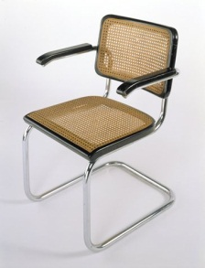 One of Marcel Breuer’s most famous pieces of furniture is the B32 chair, produced in 1928. This chair is very refined and established the production of cantilevered chairs in the 1920s. The structure was made of chromium-plated steel tubes bent in a way that the chair cantilevered. He added a wooden frame to the seat and back of the chair, which enhanced the color contrast between those elements and the polished steel. Those pieces also served as a way to contribute to the actual strength of the structure without including any cross pieces or hidden tubes.

Germany, 20th c. AD

Breuer took this design even further in the B64, which is the armchair version. In this chair, the arms elegantly float above the seat of the chair.

One architect that was inspiring to other people in the field and who shared some of the same inspirations as Breuer was Eileen Gray. She shared ideals with designers such as Le Corbusier, Charolette Perriand and Mies van der Rohe. Gray is now seen as one of the most important furniture designers and architects of the 20th century. Her work has inspired both modernism and Art Deco. Throughout her career, Gray was an independent woman. As a woman just starting off, she was not allowed access to supportive networks, she didn’t have a powerful male mentor to work with, and she didn’t share her trajectory with other artists. She did, however, overcome all of those obstacles and become a great designer.

Gray worked as a lacquer artists, furniture designer, and then as an architect. She began to design while making lacquer panels for certain clients and also designing lamps and rugs for the same projects. In 1924, while working with architecture critic Jean Bondovici, she collaborated on the construction of a house E-1027. The E-1027 project was completely finished in 1929. She also designed the furniture for this project. In the 1930’s she built a small house for herself, and met the challenge of living and designing for the small space. She developed space saving devices such as the S-Chair and a double sided chest of drawers. Among the pieces created for the E-1027 house was the Bibendum armchair.

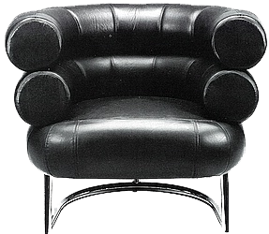This rotund chair was inspired by the experiments with tubular steel done by Breuer. The frame of the chair is chromium-plated steel tubing, with a seat of beech wood frame with rubber weaving. In 1968 there was a revival of Gray’s works, especially the Bibendum chairs and the E-1027 table.

France, 20th c. AD

Another designer who was influenced by the designs of Thonet’s bentwood is Paul Kjaerholm. Kjaerholm was a trained carpenter who had an interest in different types of construction materials. He had a special preference for steel, which he considered to be a natural material. However, when he used steel he would always combine it with other materials like leather, wood, or marble.

Kjaerholm developed his artistic ideology quite early in his career. He focused on the contrast between architectural and sculptural aspects, which he achieved by placing furniture in an architectural space. His designs can be characterized by the clean lines, amazing attention to detail, and the understated elegance. During his career, from 1951 to 1967, he developed his own collection of furniture designs.

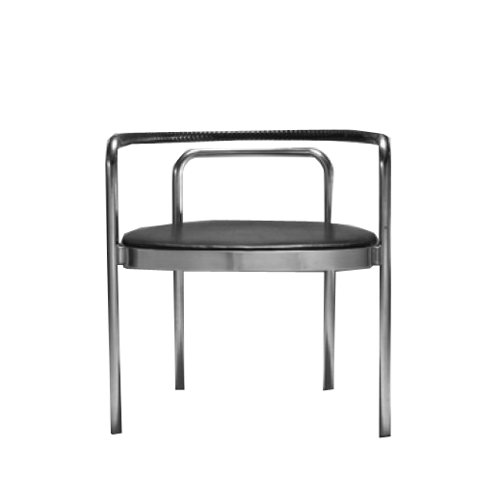 One of the pieces from The Kjaerholm Collection is the PK12 chair, or armchair 12. This chair is made of two bent steel tubes that form the legs, arms, and back and is fixed to a flat section steel seat frame. The flat seat pad is upholstered with natural canvas, parchment paper, or leather with a matching braided cover on the top rung. The structure of this chair relies completely on the strength of the seat frame, to hold the other two elements in place. Kjaerholm was influenced by Thonet bentwood forms when creating this chair. However, this design expresses a fresh way to use the properties of tubular steel.

America, 20th c. AD

The Butterfly Chair, or “BKF” chair, features a folding frame with a large cloth seat. The “BKF” stands for Antonio Bonet, Juan Kurchan and Jorge Ferrari Hardoy, the partners of Grupo Austral, which produced the chair, although Ferrari-Hardoy is solely credited for the design. Designed in 1938, the chair has actually evolved from a wooden frame “campaign chair” to its current style.

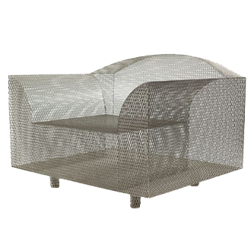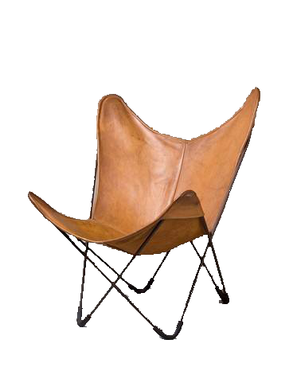The butterfly chair was originally designed for an apartment and soon became famous due to its superb design. It had been chosen to exhibit in Museum of Modern Art after it showed at the *3rd Salon de Artistas Decoradores* (1940) in Buenos Aires, Argentina. World War II was in full swing, and although Argentina did not participate in most of the war, it still suffered a coup d’état which led to an economic disorder. The poor economy led to widespread discontent among the country. In fact, between 1860 and 1930, Argentina economy’s flourished through exploitation of the pampas. It became the 10th wealthiest nation in the globe by 1913. The previous mentioned political issue spoiled the progression. Until recent, the economy is considered recovered. In term of architecture, the country is

Argentina, 20th c. AD

strongly influence by Spain, the colonist, as well as France and Italy. Fine art, likewise, was influenced by the other countries. Muralism and lithographs started to prevail in1920s.

How High the Moon is a chair designed by Shiro Kuramata in 1986. It’s constructed in strong steel mesh with no interior structure. The designer attributes this lack of structure to modernization. After industrialization and post-industrialization, people invested more effort on investigating new technology and diversifying materials, giving designers more options to create unique pieces. The world economy was growing rapidly, accelerating the capital accumulation. Japan became much stronger in term of economy throughout postwar period. Rapidly catching up with western countries, Japan became the second largest economy in 1968. By the late 1980s, the economy miracle maker suffered a huge economic blow as they slow down their growing pace. Japan’s Industrial Revolution began in 1870s when the dominant country realized the merit of industrialization and became determined to catch up with the western countries. The first noticeable event was when Japan found a new Western-based education system including study aboard such as the Iwakura Mission. It enabled the country to catch up with a more advance and systematic way of managing. Secondly, the Japan Empire declared wars with China and Russia in order to extend its territory. The country had an unstoppable pace in terms of development until World War II. The WW II defeat accompanied with two atom bombs and the invasion of Manchuria by Russia led to the Japanese loss of all the overseas property. However, the country wasn’t discouraged for too long. Japan improved its economy significantly by supplying UN forces during the Korean War. Its continuous high performance in the economy kept shortening the gap between Western countries and itself.

The art of postwar period shows a great diversity, with traditional ideas enduring throughout the years. Artists attempted art from the mainstream. In the later time, they made a step further to pioneering postwar genres such as performance art and installation art. One thing to point out is that American art has great influence on Japan and vice versa. In recent decades, more people participate in either traditional ink and brush painting or western contemporary art.

In all its forms, metal has been an important medium for furniture makers throughout the ages. Originally used for its practicality, iron developed a prestigious status and become a more elaborately used material in response to the times preferences. As time passed, new technologies and skills developed and iron was able to be used for an even greater variety of products. The ability to cast iron allowed the once prestigious material to be accessed by the masses and be represented in myriad elaborate forms. The final development of steel allowed for a simpler look and was embraced by the modern period.

Bibliography

Meadmore, Clement. *The Modern Chair: Classics in Production*. London: Studio Vista, 1974. 139. Print.

Wilk, Christopher. *Thonet: 150 Years of Furniture*. Woodbury, NY: Barron's, 1980. 98-100. Print.

Pina, Leslie A. "Tubular Steel Furniture." *Furniture in History: 3000 B.C.-2000 A.D.* Upper Saddle River, NJ: Pearson Education, 2009. Print.

Gatje, Robert F. "Master." *Breuer.Intro*. Web. 15 Feb. 2012. <http://www.marcelbreuer.org/Biography.html>.

"Eileen Gray Bibendum Chair." *Bonluxat*. Web. 15 Feb. 2012. <http://www.bonluxat.com/a/Eileen_Gray_Bibendum_Chair.html>.

"Eileen Gray / Design Museum Collection : - Design/Designer Information." *Design Museum London*. Web. 15 Feb. 2012. <http://designmuseum.org/design/eileen-gray>.

"Danish Furniture." *Poul KjÃ¦rholm*. Web. 15 Feb. 2012. <http://www.danish-furniture.com/designers/poul-kjaerholm/>.

"Poul Kjærholm - Designers - Fritz Hansen." Fritz Hansen (est. 1872) - exclusive design furniture - Fritz Hansen. N.p., n.d. Web. 15 Feb. 2012. <http://www.fritzhansen.com/en/designers/poul-kj%C3%A6rholm>.

"The Complete History of Wrought Iron." *Timeless Wrought Iron History*. Web. 01 Mar. 2012.

<http://www.timelesswroughtiron.com/history-of-wrought-iron-s/18.htm>.

"Wrought Iron Mission Craftsman Style." *Wrought Works*. 10 May 2011. Web. 01 Mar. 2012.

<http://wroughtworks.com/wrought-iron-mission-craftsman-style>.

James L. McClain, *Japan: A Modern History* (2002) pp 562-98

[**^**](http://en.wikipedia.org/wiki/History_of_japan#cite_ref-72) G.C. Allen, *Short Economic History of Modern Japan* (1972)

Swisher, Clarice, ed. *Victorian England* (2000).

Nicholas Dixon, "From Georgian to Victorian," *History Review,* Dec 2010, Issue 68, pp 34-38